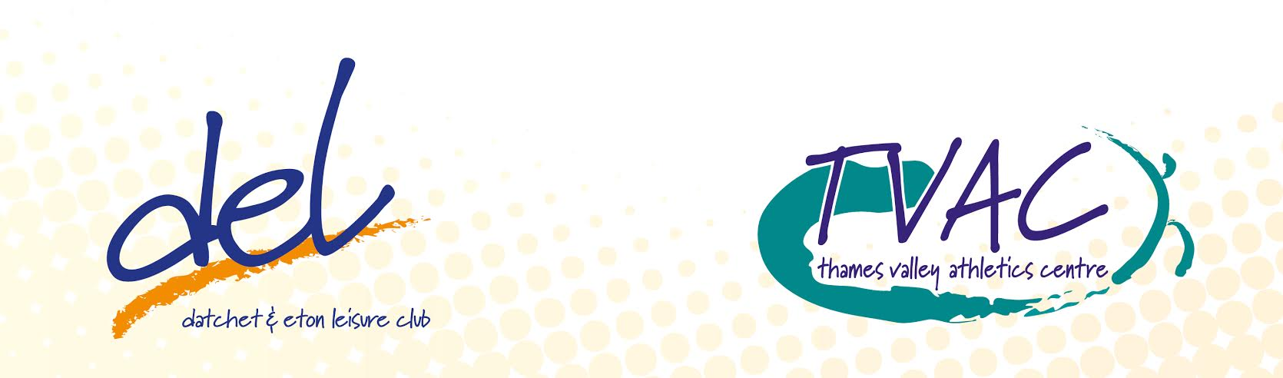

Make This Year Your Year – Terms and Conditions
Offer open 2nd January, 2018 – 31st January, 2018

- Offer only valid for ages 17 and above.
- Offer only valid on a 12-month contract.
- Offer only valid on direct debit memberships.
- The discount is applied with your first direct debit collection. If you are due to pay for a month upfront, then you will pay a full or pro rata membership payment.
- Club rules and all normal terms and conditions apply to all memberships.
- Offer only valid on full individual, off peak, joint and prestige 12 month contracts.
- No joining fee (normally £40)
- If your joining onto an additional member’s membership the current member is not entitled to the offer.
- Three months half price is off your first three months on the direct debit, so you will pay a pro rata for the full amount upon joining.
- Sign up available online or at reception. If you sign up online the offer will be processed 24 hours after joining.
- For questions please email membership@deleisure.com or call 01753 770037

Datchet & Eton Leisure
Thames Valley Athletics Centre,
Pococks Lane,
Eton,
SL46HN
01753 770 037

