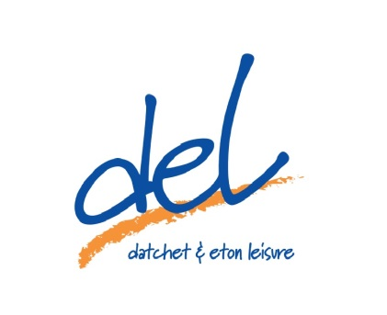
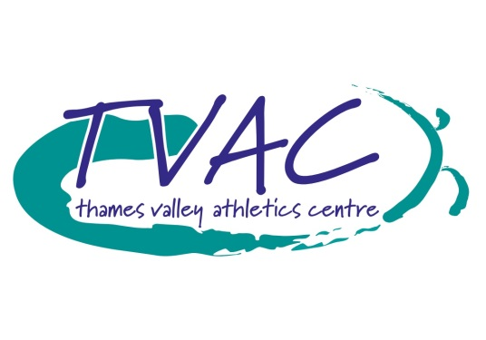

Get Fit For Summer

This offer will run from 13/4/2016 until 31/5/2016
This offer is only valid for 12 month direct debit contracts
If you join after the 18th of the month, you will need to pay for the following month up front
The 25% discount will only be applied to direct debit payments, not to any payments made at the time of joining
By signing up to a direct debit contract, you are signing up to a rolling contract. This means that after your initial period, i.e. 12 months, payments will continue to be taken unless you give one month’s written notice to cancel
There is no joining fee payable for this membership
This offer is not available to any individual who has previously been a member within the last three months
Applicants must agree to the Club Rules and sign the necessary membership forms

